Raynen® Computer Control System for Fully Automatic Sock Machine

Operation Instruction
V2.0

Fujian Raynen Technology Co., Ltd.
January 2020

Contents
Contents 1
I. Overview 3
1.1 Precautions for Safe Use 3
1.2 Main Features 3
II. Home Screen 6
Function Description 6
III. RUN 7
3.1 Description of parameters on the current chain page(①) 7
3.2 Description of parameters on the state control page(②) 7
3.3 Description of parameters on the file information page(③) 7
3.4 Description of knitting parameters (④) 8
3.5 Indication of knitting position indication (⑤) 8
3.6 Display of pattern view (⑥) 8
3.7 Description of Button Functions (⑦) 8
IV. Test 10
4.1 Selectors 11
4.2 Valves 12
4.3 Motor 13
4.4 Alarm Input 14
4.5 Aging test 14
V. Setting of Parameters 15
5.1 Work para 15
5.2 System para 17
5.2.1 System parameters 17
5.2.2 Setting of elastic yarns 19
5.2.3 Configuration of pneumatic valves 20
5.2.4 Quick resetting 20
5.3 Mach para 21
5.4 Clock 23
5.5 BTSR para 24
5.6 Update 25
5.7 Product Info 27
5.8 SOCK import 28
5.9 Para Manage 28
5.10 Encryption 29
VI. FILE 30
6.1 Edit 31
6.1.1 Action management 33
6.1.2 Jacquard 34
6.1.3 Density data 35
6.2 Preview 35
6.2.1 PATEdit 37
6.2.1.1 Pattern Loop button 38
6.2.1.2 Main Shuttle Setting button 39
6.2.1.3 Heel Color Change button 40
6.2.1.4 Heel jacquard button 41
6.2.1.5 WgLP button 42
6.2.1.6 MixColorSetting button 43
6.2.1.7 HC up button 44

I. Overview

1.1 Precautions for Safe Use
1. The safety protection shall be provided for the power line of the Sock Machine (“the Machine”), and no load can be placed on the power line;
2. The Machine must be grounded properly. Any improper grounding will lead to electric shock and the safety and reliability of the Machine;
3. Non-professional personnel is not allowed to repair and debug the Machine, which will reduce the safety performance of the Machine, increase the faults and even cause casualties.
4. The Machine shall not be operated if the protective cover of moving parts is defective.
5. The Machine shall not be operated in places with dust, corrosive, flammable and explosive gases and moisture.
6. Insulation test shall not be carried out on the input and output circuits of the controller directly, or otherwise the electric parts will be damaged.
7. The working pressure of the Machine shall be higher than 6 kg/m2, or otherwise the valve may malfunction.
8. When the Machine is running, it is forbidden to touch any moving parts, or otherwise casualties may be caused.
9. Please use the spare parts and wear-and-tear parts provided by Raynen.
10. Always use quality-assured U disks.
11. Raynen is not responsible for any consequence of unauthorized modification of the Machine.

1.2 Main Features
1. The Machine is provided with a 10.1” LCD color full touch capacitive screen which is simple and friendly in operation;
2. Integrated design of main control, power supply, servo, pneumatic\solenoid valve drive box, dual-core structure and integrated control facilitate the installation and maintenance;
3. Integrated PFC digital power supply, requiring no power frequency transformer and compatible with single-phase and three-phase wide range AC voltage input, features simple design, reliable performance and energy efficiency;
4. Faults in pneumatic\solenoid valve drive box can be detected and positioned intelligently;
5. Needle selectors, the stepping motor, the servo, air valves, ground straps, probes and other driving outputs, are characterized by intelligent self protection and self-recovery design and require no fuse change.
6. The servo flexible rapid rotation technology is adopted, contributing to accurate positioning and smooth and efficient operation;
7. Due to the innovative heat dissipation design technology, the whole machine requires no cooling fans, thus being more efficient and energy-saving;
8. Oil-proof design of whole wire rod is adopted;
9. The operating box supports the operation through the mouse, so if you insert the mouse into the USB interface, you can operate the interface;
10. With the large-capacity memory and the advanced compression technology, up to 5,000 patterns can be stored.
11. External USB interfaces are provided for the access to patterns, chains, configuration files and system parameters;
12. Network interface are configured to support networked production and management.
13. Six needle selectors ×16 cutting tools can be driven at most by the 6-wire stepping motor, and 60-/70-/80- wire and other pneumatic\solenoid valve drive boxes are available;
14. The innovative BTSR electric eye acquisition technology is adopted to enable the fast and accurate detection, and support the real-time monitoring and alarm of single needle winding and wire breaking;
15. The innovative elastic yarn motor control technology is adopted so that the motor can rotate or stop at a high or low speed by closely following the needle barrel, to ensure the consistency of the output of the elastic yarns;
16. Parameters and password protection is supported;
17. Multiple languages are supported;
18. Continuous knitting after power failure is supported;
19. The angle of double press needles and teasing needles are adjusted to optimize the overall braiding stroke and improve the operation efficiency;
20. Heavy Color for Main Shuttle, Heavy Color for Yarn Adding, Patterning and other functions are supported;
21. Double graphical display of position and pattern drawings makes the operation more intuitive and convenient;
22. Before and after the heel knitting, perfect pattern connecting can be realized in the null position and the 3C heeling function is supported.

II. Home Screen
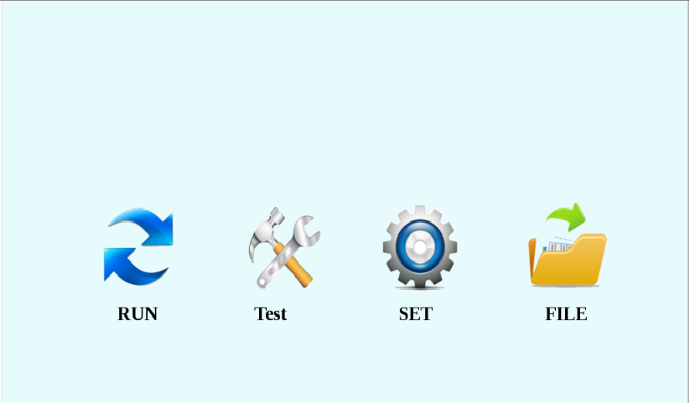

Function Description
RUN: enter the Braiding Interface.
Test: Needle selector, solenoid valve, motor and other function test.
SET: working parameters, system parameters, model parameters, system upgrading and other settings.
FILE: Import or export of pattern files, selection of patterns, pattern editing and preview, etc.

III. RUN
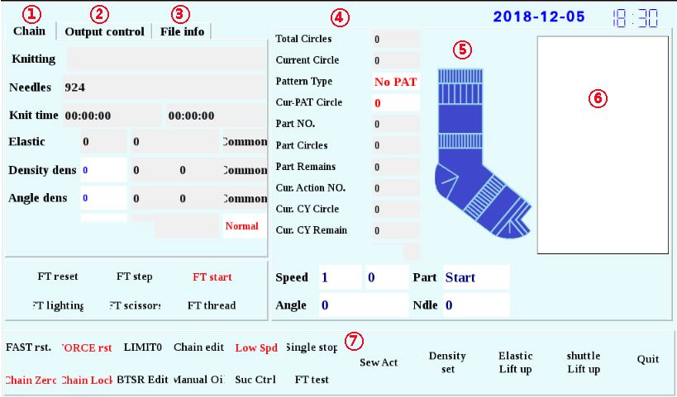

3.1 Description of parameters on the current chain page (①)
Knitting: the name of pattern file that is running.
Needles: total number of needles for the current pattern.
Knit time: the knitting time of the former sock and the knitting time of the current sock.
Elastic: initial speed, gradual speed, type of work (regular and gradual).
Density dens: initial density, gradual density, type of work (regular and gradual).
Angle dens: initial density, gradual density, type of work (regular and gradual).
Sew state:

3.2 Description of parameters on the state control page (②)
Knitting: the name of pattern file that is running.
Output: the total amount of hosieries planned to produce.
Current output: the number of hosieries produced.

3.3 Description of parameters on the file information page (③)
List of working patterns
Total output and current output of the corresponding patterns.

3.4 Description of knitting parameters (④)
Total Circles: the total number of loops required to knit the current sock.
Current Circle: Current number of knitted loops for the current sock.
Pattern Type: Whether there is a pattern or not.
Cur-PAT Circle: All laps of the pattern.
Part NO.: the serial number of the current position.
Part Circles: the total number of loops required to knit the current position.
Part Remains: the number of loops to be knitted for the current position.
Cur. Action NO.: the serial number of the action used for the current loop.
Cur. CY Circle: the total number of loops of the current action.
Cur. CY Remain: the total number of remaining loops of the current action.
Speed: Current knitting speed.
Angle: Current knitting angle.
Part: the name of the current knitting position.
Ndle: the needle position of the current knitting.

3.5 Indication of knitting position indication (⑤)
Indicate the position of the position of the sock that is knitted currently.

3.6 Display of pattern view (⑥)
Display the current working pattern and the color of the current working pattern.

3.7 Description of Button Functions (⑦)
FAST rst: Press the button to enter the fast reset mode. The current knitting position automatically executes the chain normalization and enters the fast reset for chain knitting, so that the Machine can safely return to the reset state.
FORCE rst: Press the button to enter the hard reset mode. The coil falls off after the needle cylinder turns two rounds and password confirmation is needed when the hard reset is performed in special parts.
LIMITO: the knitting speed is limited according to the set speed, ranging from 0 to 400.
Chain edit: Press the button to enter the command editing page or action editing page according to the prompt box, and a password is required to edit the action.
Low Spd: Press the button to run at a maximum speed of 80 rpm, and press again to cancel the limitation.
Single stop: the Machine automatically stops knitting after the knitting of the sock is completed.
Chain Zero: Press the button to execute the actions of all parts only once in turn.
Chain Lock: knit the current loop repeatedly.
BTSR Edit: When the electric eye learning button is selected, the system enters the electric eye learning mode; when the electric eye learning button is canceled, the system enters the knitting mode.
Manual Oil: After pressing the button, refuel for 5 seconds and pause for 5 seconds, and repeat until you press the button again to stop refueling.
Elastic Lift up: press the button, then the elastic yarn shuttle exits the working position; press it again, the elastic yarn shuttle enters the working position.
Suc Ctrl: Press the button to control the start and stop of the suction.
Density set: press the button to enter the density setting interface.
shuttle Lift up: Press the button, then the elastic yarn shuttle exits and all the yarn-adding shuttles, main shuttles and elastic yarn shuttles are lifted; press it again, they restore to the previous state.

IV. Test
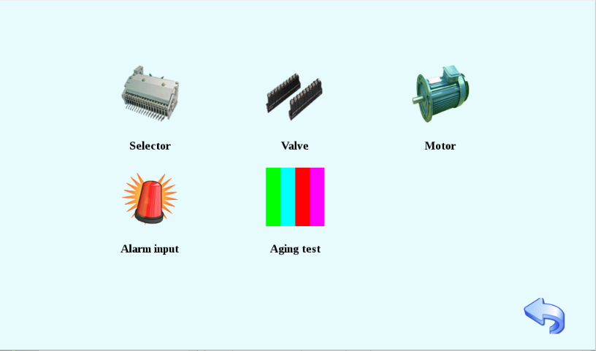
Function Description
Selector: enter the test interface of the needle selector.
Valve: enter the test interface of solenoid valve.
Motor: enter the motor test interface.
Alarm input: display all alarm signals of the system.
Aging test: enter the aging test interface of the needle selector.
4.1 Selectors
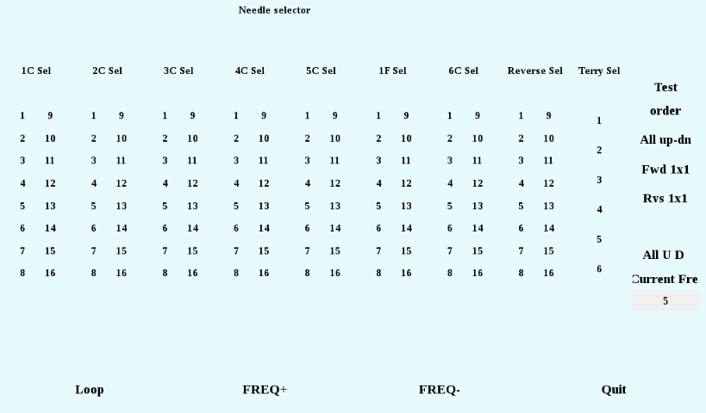
Description of test modes
order: click on the button and turn it on or off sequentially from 1 to 16.
All up-dn: click the button to open all 1 to 16 sections, and then click it again to stop all.
Fwd 1x1: click the button to open sections with odd numbers, and then click it again to stop them.
Rvs 1x1: click the button to open sections with even numbers, and then click it again to stop them.
All U D: click the button to open all 1 to 6 sections of the need selector, and then click it again to stop all.
Current fre: display the interval of the switching of sections in the needle selector under the current test.
Description of button functions
Loop: the selected test mode is executed iteratively at intervals.
FREQ +: reduce the cycling interval.
FREQ -: increase the cycling interval.

4.2 Valve
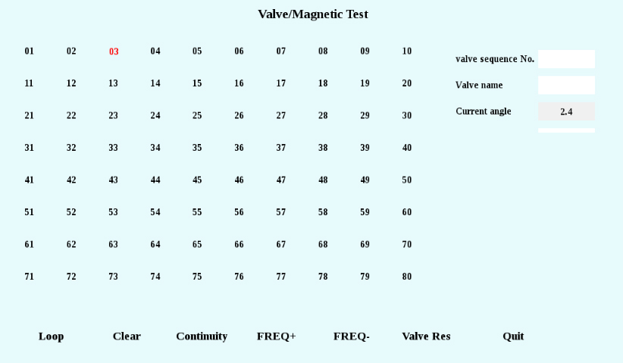
Description of parameters
Valve sequence No.: the serial number of the pneumatic valve selected currently
Valve name: the name of the pneumatic valve selected currently
Current angle: the angle of the current servo motor.
Description of button functions
Loop: turn the pneumatic valves on or off sequentially from 1 to 80 at a certain interval.
Clear: turn off all pneumatic valves.
Continuity: turn on or off the selected pneumatic valves successively at a certain interval.
FREQ +: reduce the cycling and continuing intervals.
FREQ -: increase the cycling and continuing intervals.
Valve Res: test the impedance of all pneumatic valves.
4.3 Motor
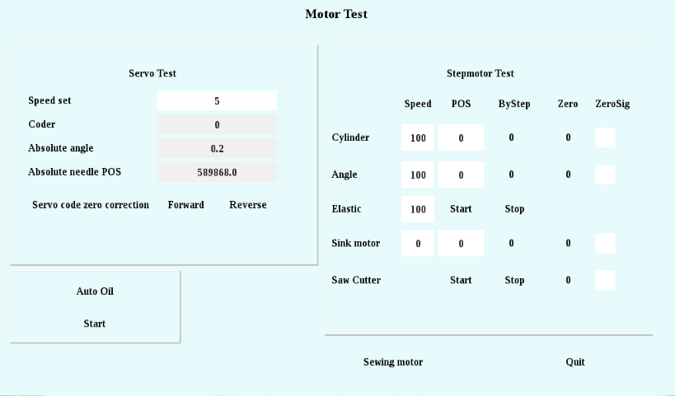
Description of main functions and parameters
Servo Test
Speed set: motor speed set at 5-400.
Coder: display the coded value of the encoder.
Absolute angle: display the absolute angle of the current servo motor.
Absolute needle POS: display the absolute needle position of the current servo motor.
Servo code zero correction: only used in the all-in-one model.
Forward: the needle cylinder is in positive rotation.
Reverse: the needle cylinder is in inversion.
Stepmotor Test
ByStep: the motor rotates to the designated position.
Zero: the motor rotates to the zero position.
Auto Oil
Click on the button to start refueling according to the working parameters of the automatic refueling mode.

4.4 Alarm Input
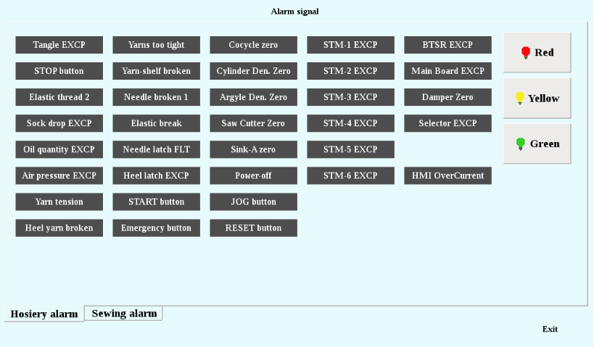
Description of main functions and parameters
Perform alarm signal input test and test the sensitivity of all alarm signals.

4.5 Aging test
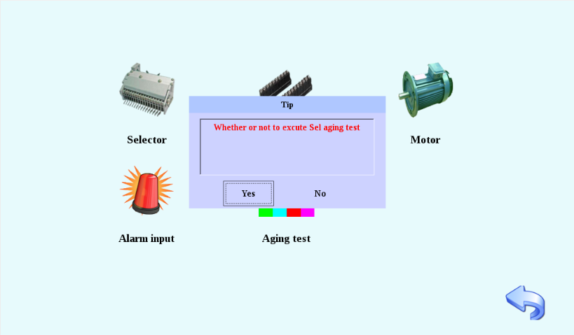
Perform aging test of the needle selector and test each needle selector repeatedly and automatically.
V. Setting of Parameters
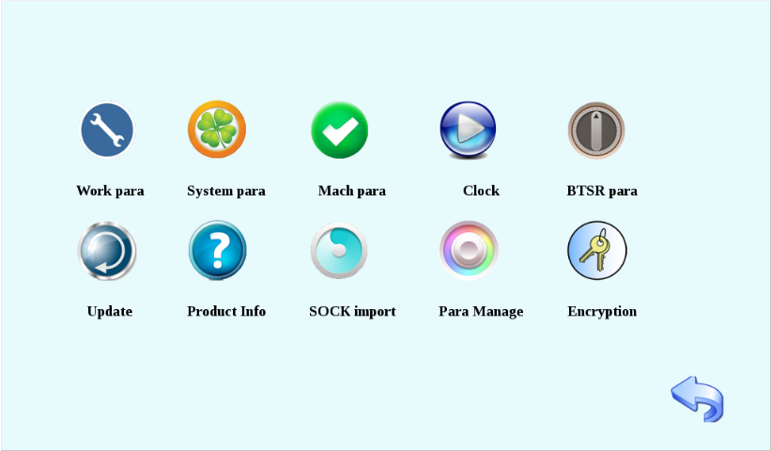

5.1 Work para
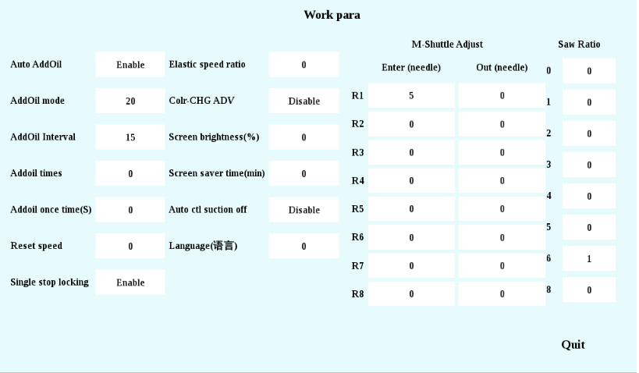
Description of main functions and parameters
Auto AddOil: 0 invalid, 1 valid.
AddOil mode: 1. by output; 2. by time; 3. by number of loops.
AddOil Interval: The interval between neighboring two refueling operations should be 0 to 1,000 seconds.
Addoil times: the refueling times in fixed mode.
Addoil once time: refueling duration should be 1-60 seconds.
Reset speed: the reset speed of the motor, ranging from 10 to 100.
Single stop locking: 0 invalid, 1 valid.
Elastic speed ratio: 1-200. The speed percentage of the elastic yarn motor can be adjusted to 200 at most, that is 200%, twice of the original speed.
Colr CHG ADV: set the color change function of the main shuttle as 0 invalid and 1 valid.
Screen brightness: set the brightness value of the screen at 30-99.
Screen saver time: 0-60; the screen saver is closed at 0.
Language: select the system language: 0 for Chinese, 1 for English.
Auto ctl suction off: 0 invalid; 1 valid.
M-Shuttle Adjust: the advancement of each main shuttle can be fine-tuned at entering and exiting positions separately during the main shuttle color change.
Saw Ratio: the ratio between the rotational speed of the Huff disk to that of the servo motor. This ratio can be set to control the cutting length.

5.2 System para

5.2.1 System parameters
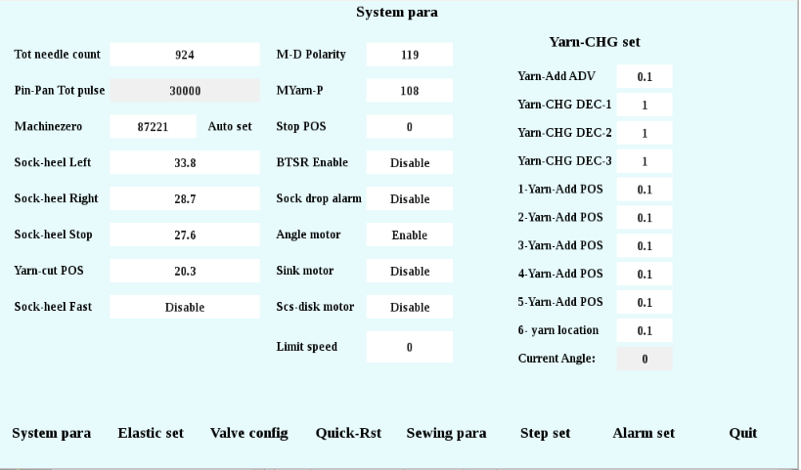
Description of main functions and parameters
Tot needle count: the total number of knitting needles on the needle cylinder, ranging from 0 to 500. After the setting of the total number of needles, the system will automatically calculate the arrangement and combination of jacquard needles.
Pin-Pan Tot pulse: display the total pulse number of the needle plate.
Machinezero: range from 0 to 360. The setting of the zero position for the Machine must be done under a hard reset mode. After pressing the Hard Reset button, turn the needle cylinder to name the No. 3 main shuttle aligning to the zero-position needle, and then click the "Automatic Setting" button to complete the setting.
Sock-heel Left: 0 - 360 degrees, the position which the heel must exceed during the positive rotation at the zero position when the heel is being knitted.
Sock-heel Right: 0 - 360 degrees, the position which the heel must exceed during the negative rotation at the zero position when the heel is being knitted.
Sock-heel Stop: 0 - 360 degrees, the position which the heel must exceed during the negative rotation at the zero position when the knitting of the heel is ended.
Yarn-cut POS: 0 - 360 degrees, the position which the heel must exceed during the positive rotation at the zero position when preparations are made for the knitting of the heel.
Sock-heel Fast: 0 invalid, 1 valid; used to automatically adjust the running stroke in the press needle and teasing needle process during the knitting of the heel, to reduce the waste of the stroke and improve the efficiency.
M-D Polarity: the polarity setting of butterfly door shuttle, ranging from 0-1.
MYarn-P: the polarity setting for main shuttles, ranging from 0-1.
Stop POS: 0 - 360 degrees, the stopping position of the main motor after the knitting is completed.
BTSR Enable: 0 invalid (turn off BTSR function), 1 valid (turn on BTSR function).
Sock drop alarm: 0 invalid, 1 valid, whether it is necessary to set the sock drop alarm.
Angle motor: 0 invalid; 1 valid, whether there is an edge angle motor.
Sink motor: 0 invalid; 1 valid, whether there is Shengke motor.
Scs-disk motor: 0 invalid; 1 valid, and whether there is a scissor disk motor.
Limit speed: The limit of the rotational speed of the servo motor.
Yarn-CHG set
Yarn-Add ADV: the advance of auxiliary shuttle operation, ranging 0 - 360 degrees.
Yarn-CHG DEC -1/2/3: 1-200, set the speed of yarn change on plate-making functional strip.
1/2/3/4/5 – Yarn-Add POS: 0 - 360 degrees, the position on the needle cylinders of 1C to 5C shuttles.
Current Angle: display the angle of the current needle cylinder.

5.2.2 Setting of elastic yarns
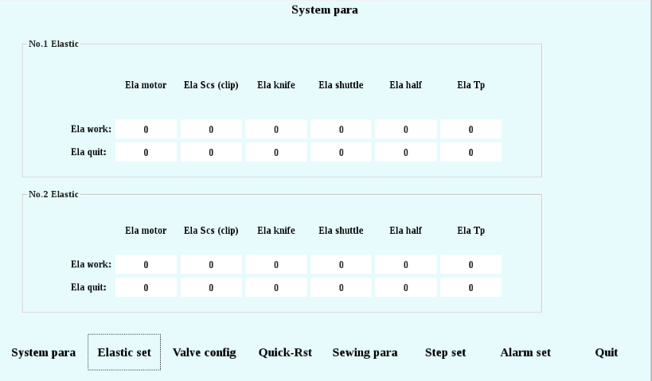
When the elastic yarn band is working, the entering and exiting positions are set in the range of 0-360 degrees.

5.2.3 Configuration of pneumatic valves
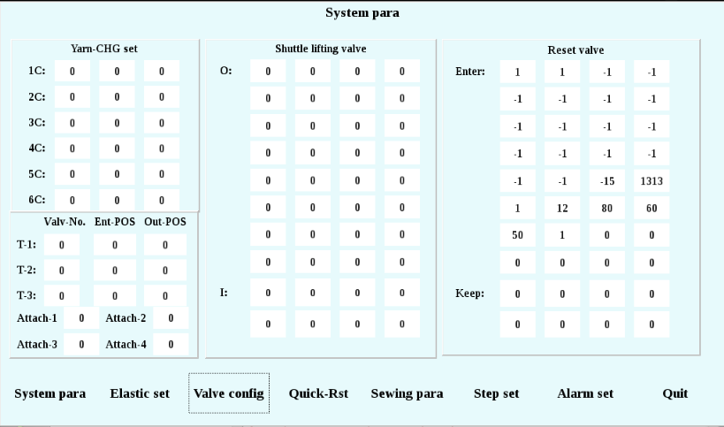
Description of main functions and parameters
Yarn-CHG set: 0 ~ 80; set the pneumatic valve numbers corresponding to 1C to 6C shuttles.
Configuration of pneumatic valves for unhairing tools
T- 1/2/3:
Valv-No.: Blade Air Valve Number Configuration, 1-80;
Ent-POS: the entering position of the pneumatic valve, ranging 0 ~ 360 degrees;
Out-POS: the exiting position of the pneumatic valve, ranging 0 ~ 360 degrees;
Attach 1/2/3/4: the valve numbers corresponding to the auxiliary function of the unhairing tools.
Configuration of Shuttle lifting valve: the pneumatic valve lifted by the shuttle in the operating menu; O: out, I: in, ranging from 1 - 80.
Configuration of Reset valve: the configuration of the hard resetting pneumatic valves.

5.2.4 Quick resetting
Quick resetting: Open the Quick Resetting Chain Editing Interface.

5.3 Mach para
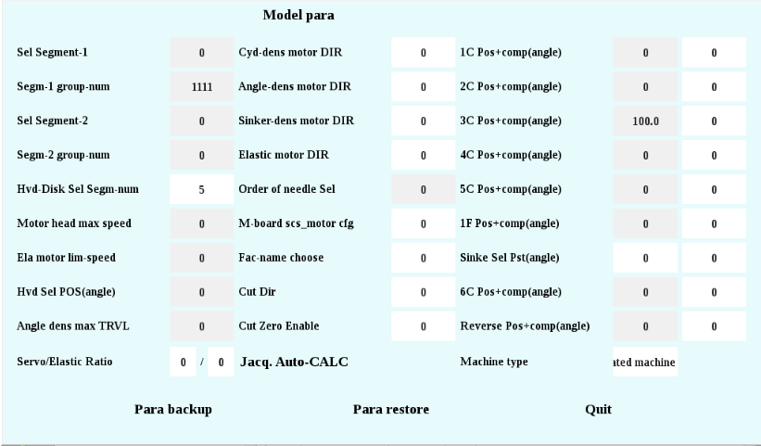
Description of main functions and parameters
Sel Segment-1: the number of needles in the section, ranging from to 1 to 18.
Segm-1 group-num: the number of No. 1 sections in the needle selectors, ranging from to 1 to 9999.
Sel Segment-2: the number of needles in the section, ranging from to 1 to 18.
Segm-2 group-num: the number of No. 2 sections in the needle selectors, ranging from to 1 to 9999.
Hvd-Disk Sel Segm-num: 1 to 18.
Motor head max speed: display the maximum rotational speed of the Main Servo.
Ela motor lim-speed: show the maximum speed limit of the main servo for the elastic yarn.
Hvd Sel POS(angle): display the maximum pulse of the needle cylinder: 2 loops, 1,600 pulses.
Angle dens max TRVL: display the maximum pulse of the needle cylinder: 1 loop, 800 pulses.
Servo/Elastic Ratio: elastic yarn speed ratio as the molecule, and the elastic yarn speed ratio as the denominator, ranging from 1-100.
Cyd-dens/Angle-dens/Sinker-dens/Elastic/Cut motor DIR: 0 refers to the direction, and 1 refers to the positive direction.
Order of needle Sel: the action sequence of the No. 1-16 blades in the needle selector: from top to bottom, or from bottom to top.
M-board scs_motor cfg: according to the machine model, select the drive module for the scissors disk motor.
Fac-name choose: According to the manufacturer name, enter the corresponding number to obtain the corresponding encryption service.
Cut Zero Enable: 0-off; 1-on.
Jacq.Auto-CALC: the arrangement and combination of jacquard needles are calculated according to the total number of needles.
1C/2C/3C/4C/5C/1F/6C/Reverse Position + Compensation (Angle): display the position (angle) of the needle selector, ranging from 0 to 360 degrees.
Sinker Sel Pst(angle): display the position (angle) of Shengke Needle Selector, ranging from 0 to 360 degrees.
Machine type: current model: 0: double-way; 1: terry flat; 2:7F; 3: all-in-one.

5.4 Clock
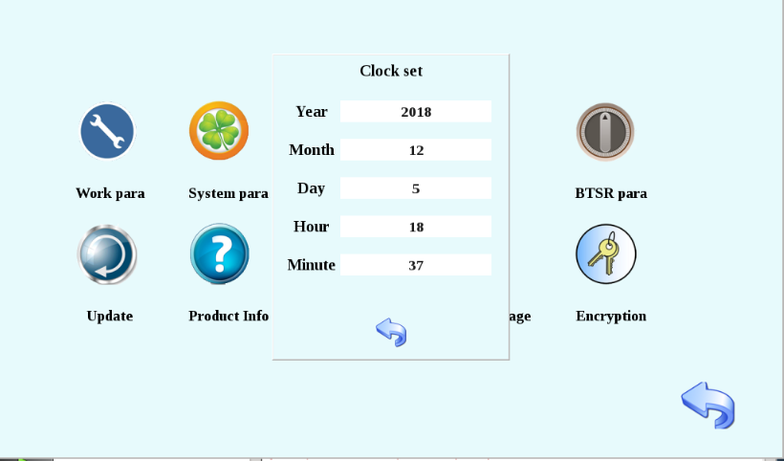
The clock setting for the current system.

5.5 BTSR para
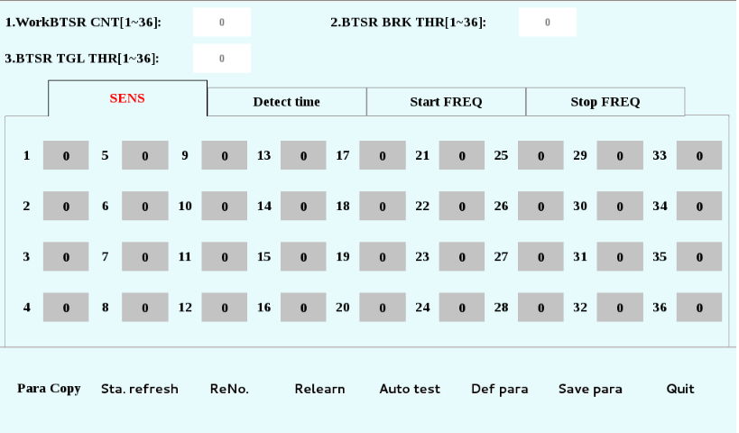
Description of main functions and parameters
WorkBTSR CNT: Set the working quantity of electric eyes for the current pattern, not exceeding 36.
BTSR BRK THR: in the knitting process, an alarm will be given when the electric eye detects that the breaking data exceeds that threshold value.
BTSR TGL THR: in the knitting process, an alarm will be given when the electric eye detects that the winding data exceeds that threshold value.
SENS: 1-10 levels, the higher the level, the more sensitive in detection of abnormalities.
ReNo.: Number the electric eyes from 1 to 36 in sequence, starting from 1.

5.6 Update
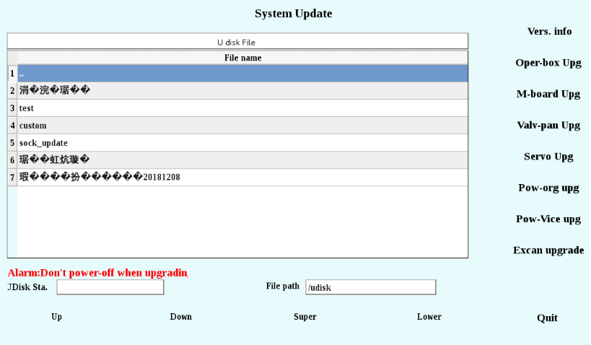
Description of main functions and parameters
UDisk Sta.: Before opening this interface, you need to insert a U-disk. After the U-disk is identified, the information of files in the U-disk will be displayed in the list of U-disk files.
Vers. info: check the version number of the operation box, motherboard, pneumatic valve plate, servo, etc.
Oper-box Upg: select the operation box upgrading file in the list of U disk files, and then click the operation box upgrading button to enter the operation box upgrading process.
M-board Upg: select the motherboard upgrading file in the list of U disk files, and then click the motherboard upgrading button to enter the motherboard upgrading process.
Valv-pan Upg: select the pneumatic valve upgrading file in the list of U disk files, and then click the pneumatic valve upgrading button to enter the pneumatic valve upgrading process.
Servo Upg: select the servo upgrading file in the list of U disk files, and then click the servo upgrading button to enter the servo upgrading process.
Pow-org Upg: select the primary side upgrading file in the list of U disk files, and then click the primary side upgrading button to enter the primary side upgrading process.
Pow-Vice upg: select the auxiliary side upgrading file in the list of U disk files, and then click the auxiliary side upgrading button to enter the auxiliary side upgrading process.
Excan upgrade: once the U disk is inserted, the system will automatically identify all upgrading files in the U disk. Click the one-click upgrading button, and enter the upgrade process to identify the upgrading files.

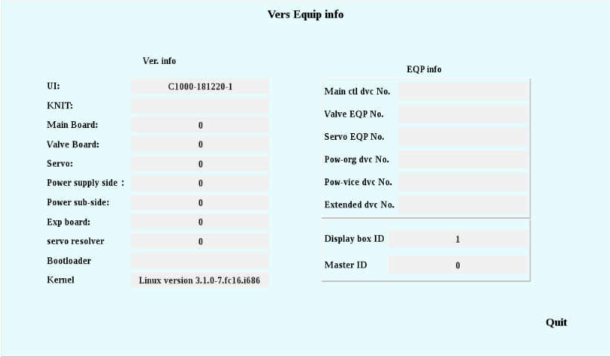
Version information of current system

5.7 Product Info
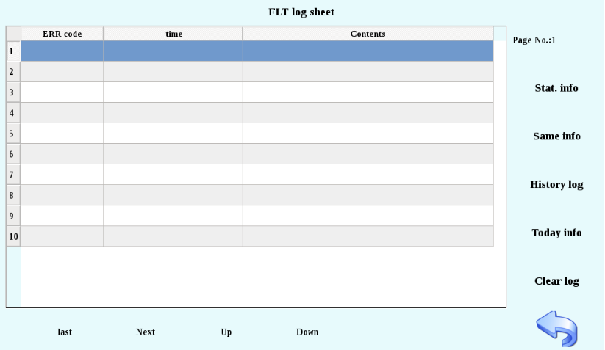
Description of main functions and parameters
Stat. info: display only the statistical information of the current line.
Same info: display all logs that with the same error code as the current line.
History log: display all logs.
Today info: display all logs with the same time as the current line.
Clear log: delete all production logs, but you need to enter a password (as follows).
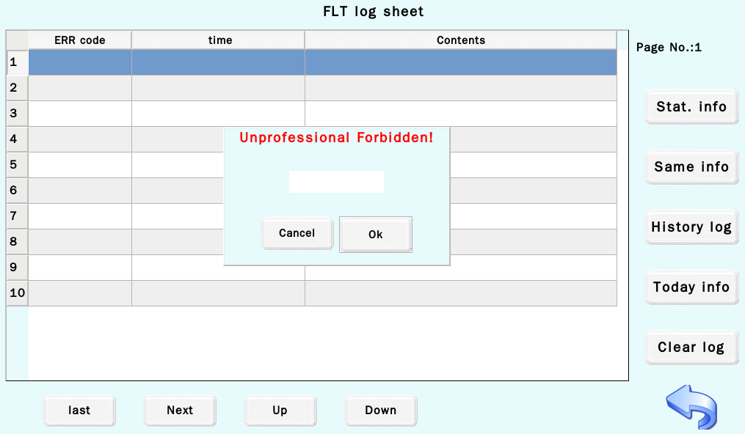

5.8 SOCK import
Import into the upgraded chain editor and pattern editor separately.

5.9 Para Manage
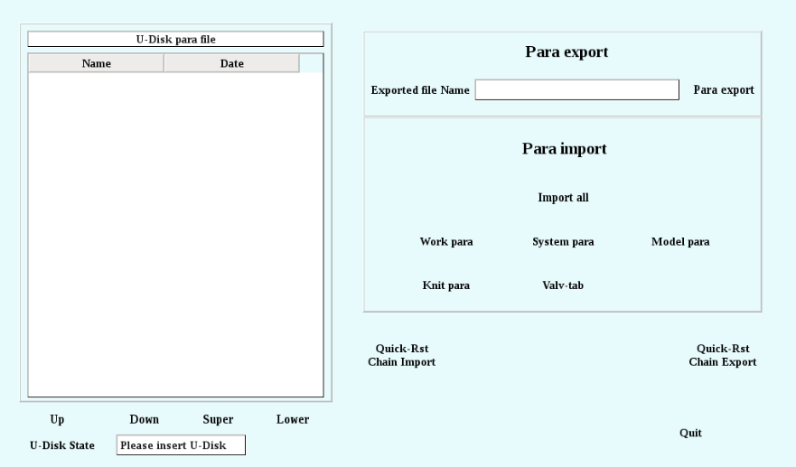
Description of main functions and parameters
Para export
Para export: export all parameters to U disk and name the parameter file with the specified file name.
Parameter import
Import all: Import all parameters in the. rnsock file into the memory.
Work para: Import the working parameters from the. rnsock file into the memory.
System para: Import system parameters from. rnsock file into the memory.
Model para: Import model parameters from. rnsock file into the memory.
Knit para: Import the knitting parameters in the. rnsock file into the memory.
Valv-tab: Import the parameters of the pneumatic valve meter in. rnsock file into the memory.
Quick-Rst Chain Import: Import the "quick_reset.101" file from the parameter file list in the left U disk into the memory.
Quick-Rst Chain Export: export the "quick_reset.101" in the fast reset chain to the U disk.

5.10 Encryption
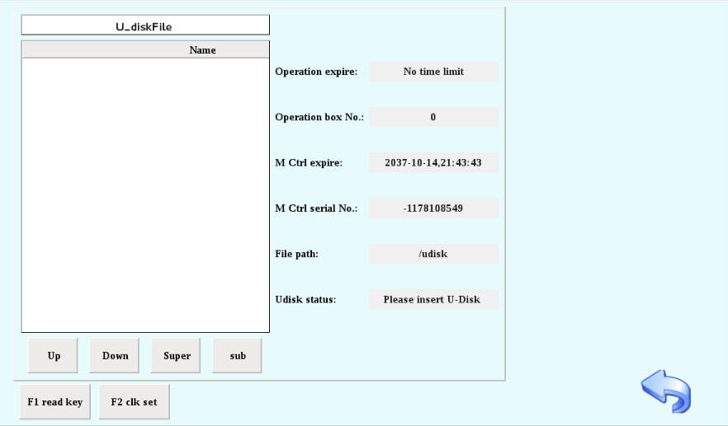
The encryption management for the installment payment for the Machine can set any time point so that an expiration notice will be given 7 days in advance.

VI. FILE
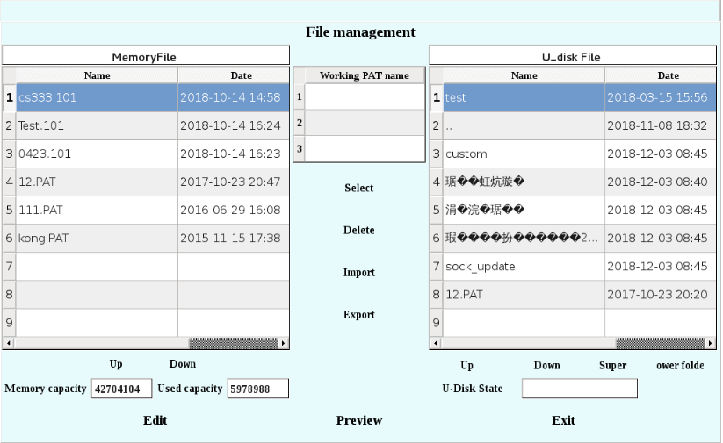
Description of main functions and parameters
Select: Select the working patterns from the memory and enter the working pattern area.
Delete: Delete the pattern files in the memory or the working pattern.
Import: Import the pattern files from U disk into the memory.
Export: Export the pattern files from the machine memory file to U disk, and you can change the pattern name now.
Up (left): turn to the previous page of the file in the memory of the sock machine.
Down (left): turn to the next page of the file in the memory of the sock machine.
Up(right): turn to the previous page of the file in the U disk.
Down (right): turn to the next page of the file in the U disk.
Super: go back to the superior folder in the current folder of the U disk files.
Ower folde: Go forward to the lower folder in the current folder of the U disk files (select a folder first).
Edit: Open the editing interface of the selected pattern files in the memory.
Preview: Open the preview interface of the selected pattern files in the memory.
Exit: Exit the current interface and return to the home screen.
6.1 Edit
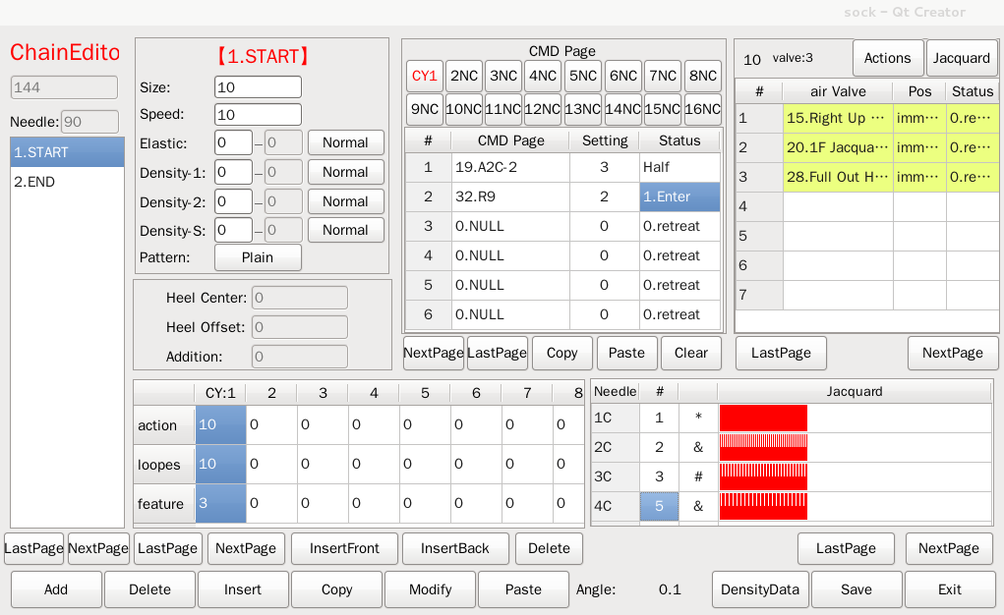
Description of main functions and parameters
Add: add a position behind the last position.
Delete: delete the selected position.
Insert: insert a position in the front or at the back of the selected position.
Copy: copy all data in the current location.
Modify: modify the name of the current location.
Paste: Paste the copied position. Before pasting the position, add a blank position first.
Last Page: scroll up to the previous page when there are many positions.
Next Page: scroll down to the next page when there are many positions.
Setting of position parameters
Size: the number of knitting loops in current position, ranging from 1 to 10000.
Speed: the running speed of the sock machine when knitting the current position, ranging from 1 to 400.
Elastic: the current elastic yarn density, ranging from 1 to 1000.
Density-1: the needle cylinder density for the current position, ranging from 1 to 32, with the specific value to be modified in the "density data" interface.
Density-2: the edge angle density for the current position, ranging from 1 to 32, with the specific value to be modified in the "density data" interface.
Patterns: with/without patterns.
Heel parameters
Heel Center: display the heel knitting center
Heel Offset: display the deviation amount of the heel knitting.
Addition: display additional items.
Setting of CY parameters
action: modify the action number of the current position, with the value ranging from 0 to 200.
loopes: modify the number of knitting loops of the action, with the value ranging from 0 to 999.
feature: modify the incidental features of the knitting action, with the value ranging 0 to 8.
Last page: scroll up to the previous page when there are many CYs.
Next page: scroll down to the previous page when there are many CYs.
Setting of command page
CMD Page: setting of commands automatically executed when knitting to the action, with the value ranging from 0 to 31.
Setting: the angle of the Machine when the command is executed, with the value ranging from 0 to 1080.
Status: the state of the command: 0: back; 1: forward; 2: stay.
Actions: enter the action management interface.
Jacquard: enter the needle selection data interface.
DensityData: enter the density data display interface.
Save: save the current changes.
Exit: exit the chain editing interface.

6.1.1 Action management
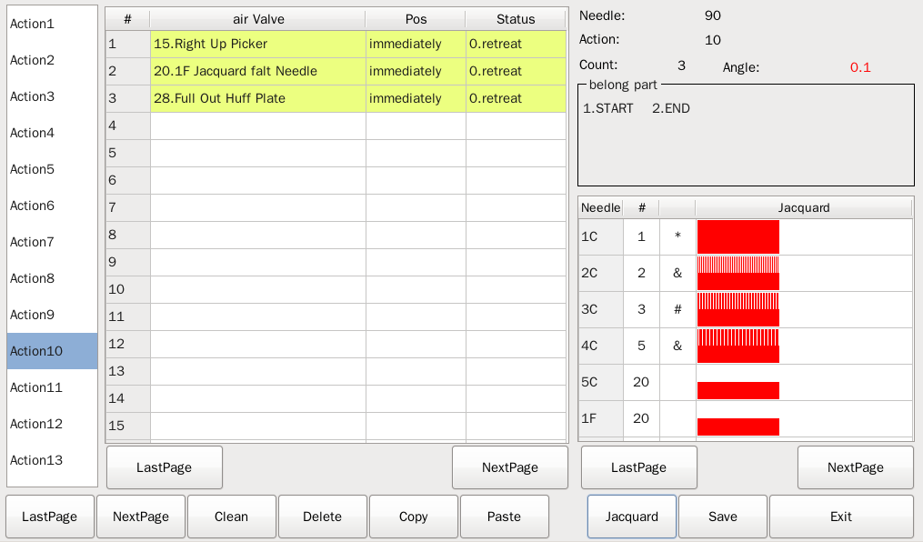
Description of main functions and parameters
Clean: empty all actions of the pneumatic valves contained in the selected action.
Delete: delete the selected action.
Copy: copy the selected action.
Paste: paste all the actions of the pneumatic valves among the copied actions to a selected location.
Air Valve: pneumatic valves included in the setting action, with the value ranging from 0 to 80.
Pos: the angle of needle cylinder of the Machine when the pneumatic valve is executed, with the value ranging from -1080 to 1080.
Status: the state of the pneumatic valve: 0: back; 1: forward; 2: stay.
Jacquard: enter the needle selection data interface.
Save: save the current action data.

6.1.2 Jacquard
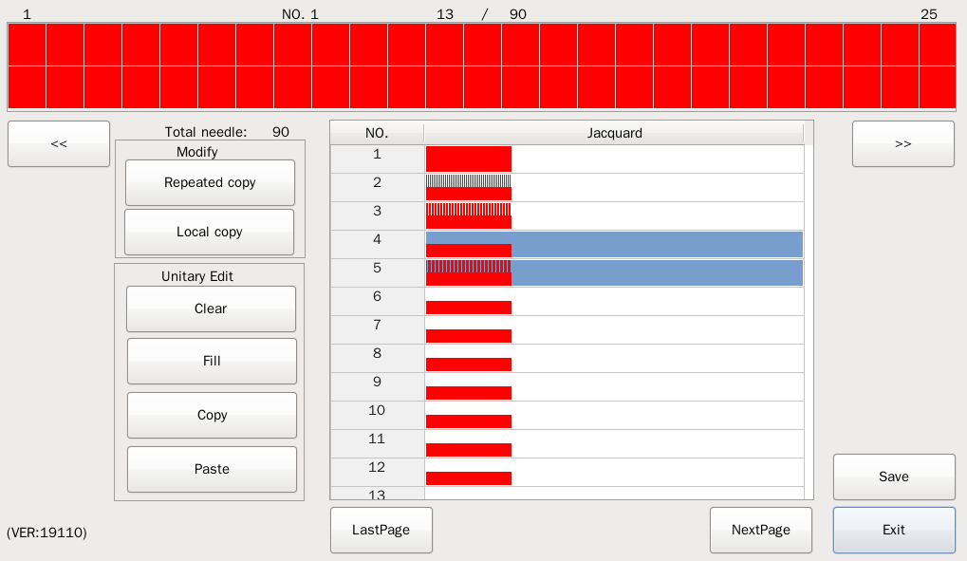
Description of main functions and parameters
Filling mode
Repeated copy: copy the selected needles between the specified starting needle and the ending needle to the corresponding position in the target block.
Local copy: copy the selected needles between the specified starting needle and the ending needle to the specified position in the target block.
Block operation
Clear: clear the selected needle in the current block.
Fill: fill the selected needle in the current block.
Copy: copy the selected needle in the current block.
Paste: paste the selected needles on the copied block to the current block.
Saving: save the current needle selection data.

6.1.3 Density data
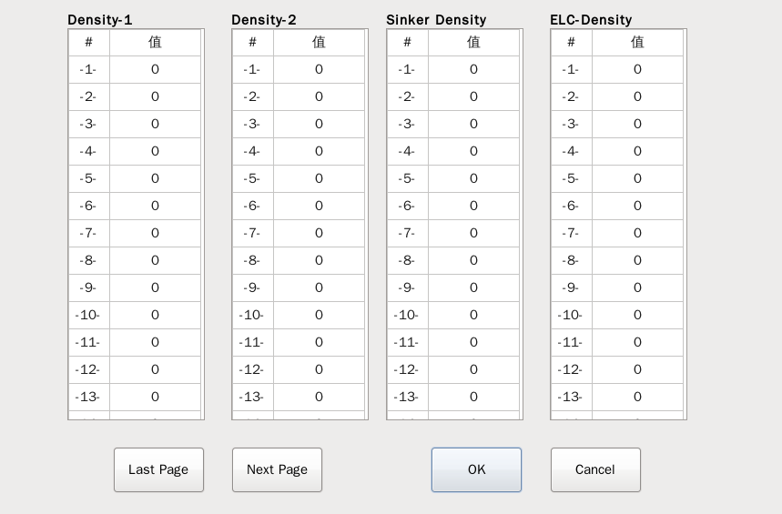
Description of main functions and parameters
Display specific density values for each level.
Density settings: ranging from 0 to 99.
6.2 Preview
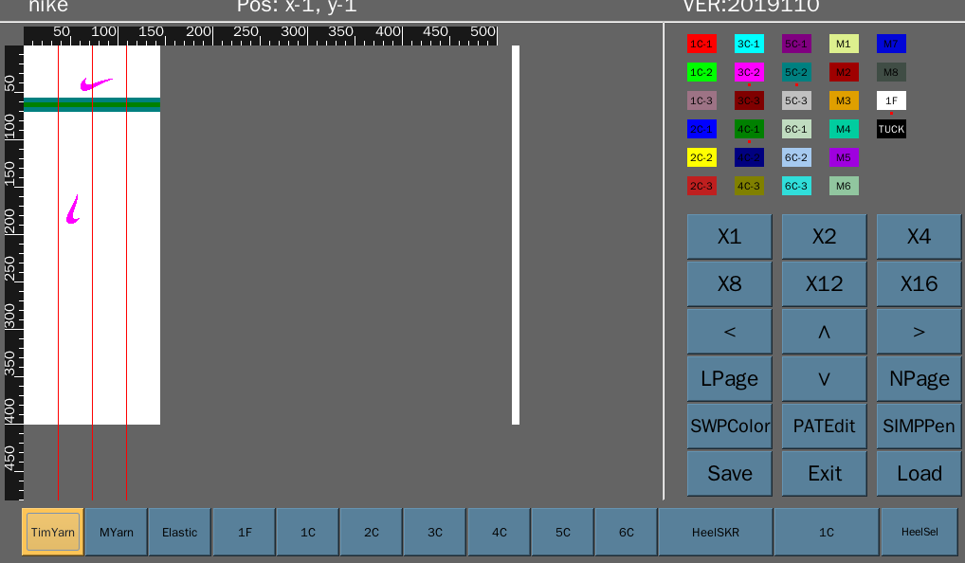
Description of main functions and parameters
TimYarn: switch to yarn adding View.
MYarn: switch to the main shuttle view.
Elastic: Switch to elastic yarn view.
1F: Switch to 1F main shuttle view.
1C: switch to 1C heavy color view
2C: switch to 2C heavy color view.
3C: switch to 3C heavy color view
4C: switch to 4C heavy color view
5C: switch to 5C heavy color view
6C: switch to 6C heavy color view
SWPColor: Open the color change view as follows
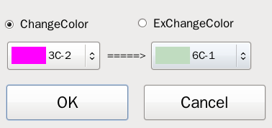
PATEdit: Open the pattern editing view.
SIMPPen: Open the simple brush view as follows.
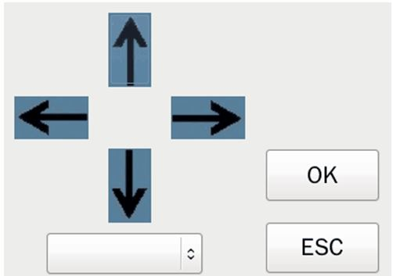

6.2.1 PATEdit
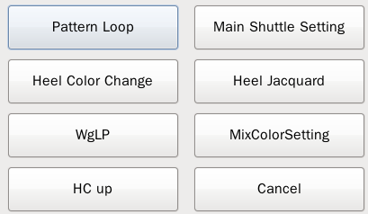
Description of main functions and parameters
Each button can open a corresponding function setting interface, to set the specific function features.

6.2.1.1 Pattern Loop button
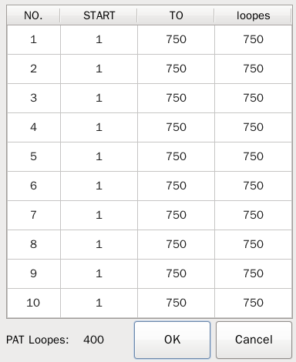
Description of main functions and parameters
Set the starting loop and the ending loop of the pattern to be knitted in a cycling mode, with the value ranges from 1 to the height of the pattern (the height of the demonstration pattern is 400).
After the starting loop and the ending loop are set, the Machine will repeat the knitting of the pattern that needs to be cycled.

6.2.1.2 Main Shuttle Setting button
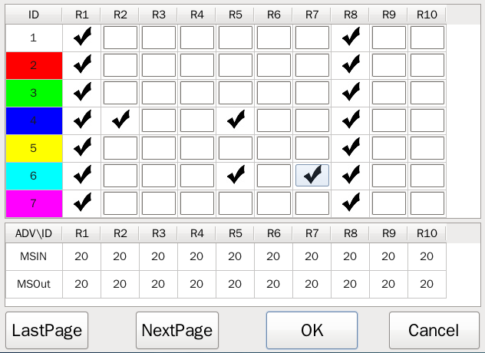
Description of main functions and parameters
The color of sock can be changed largely through the Main Shuttle Setting, which can be used in making striped sock.
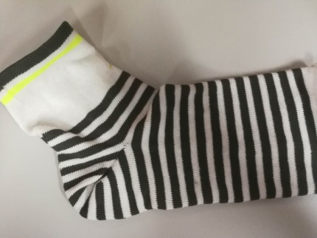(striped sock)
The color code in the Main Shuttle Setting corresponds to that in the MYarn of the plate making software. The main shuttle that should be used for each color code can be checked directly in the corresponding coordinate frame.
MSIN: corresponding to the advance of main shuttle when changing shuttle enters into knitting state.
MSOut: corresponding to the advance of main shuttle when changing shuttle exits the knitting state.
6.2.1.3 Heel Color Change button
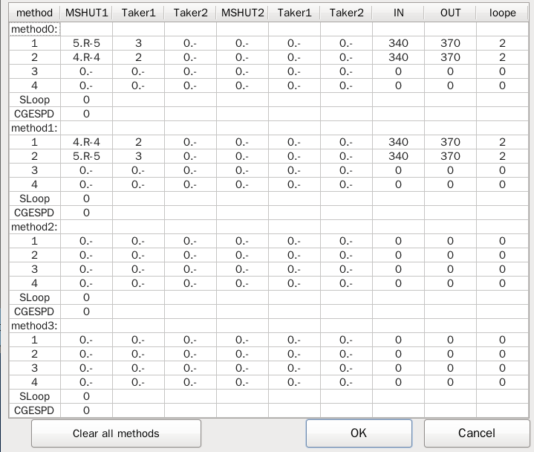
Description of main functions and parameters
The heel color change function is set to enrich the color of the heel part.
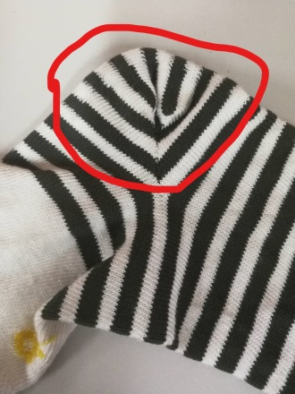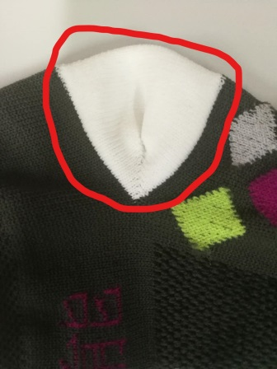
(Heels with color change) (Heels without color change)
When there is only “one main shuttle entering and one main shuttle exiting” in the heel part of sock, only the values in the MSHUT1 need to be set; when there are “two main shuttles entering and two main shuttles exiting”, the MSHUT1 and the MSHUT2 must be set at the same time.
Method 0~Method 3: Different color changing methods can be selected when knitting.
Taker1\ Taker2: Used to adjust the yarn tension.
IN: the angle at which the main shuttle enters the knitting position.
OUT: the angle at which the main shuttle exits the knitting position.
Number of loops: corresponding to the number of knitting loops of the main shuttle.
Initial loop: The first loop executing the heel color changing function in all loops at the heel position.
Thread switching speed: the speed of the main shuttle in entering and exiting the knitting position.
6.2.1.4 Heel jacquard button
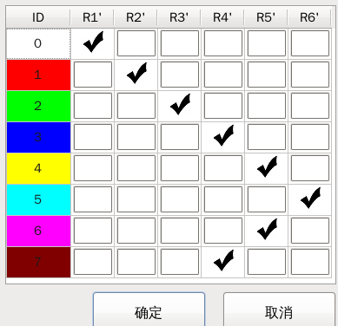
Description of main functions and parameters
The heel jacquard is used to design the pattern of the heel part deigned independently to meet more market demands.

6.2.1.5 WgLP button
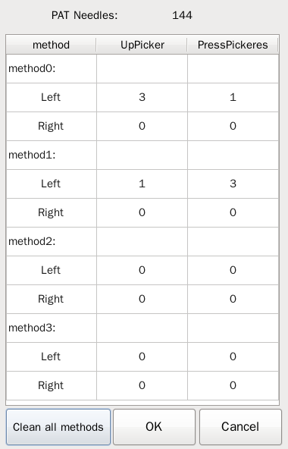
Description of main functions and parameters
Usage of WgLP
1. Distinguish the left and the right hosieries: The WgLP can make the width of the toes bigger than that of other places, and make the sock more suitable for the shape of the foot.
2. Adjust the reduction range of the heel part: the WgLP can change the times of press/teasing needles at the heel part, in order to delay or accelerate the reduction of the heel part.
method 0~method 3: Different press/teasing needle cycling methods can be selected when knitting.
UpPicker: decrease the knitting times at the heel
PressPickeres: increase the knitting times at the heel
Left: setting of numbers of the number of press/teasing needles corresponding to the left side of the heel.
Right: setting of numbers of the number of press/teasing needles corresponding to the right side of the heel.
6.2.1.6 MixColorSetting button
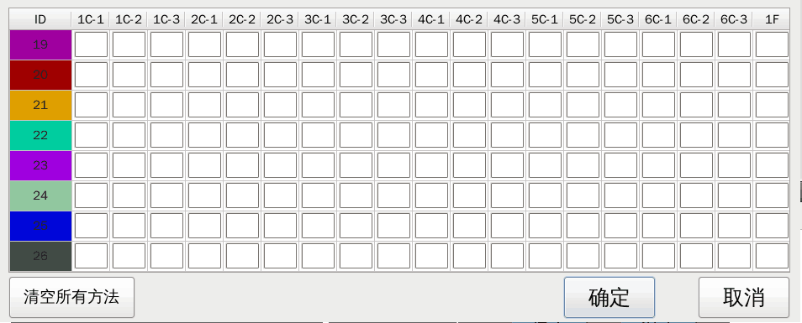
Description of main functions and parameters
Use a color code to place more shuttles into the knitting position.
The MixColorSetting function can improve the aesthetics of the sock in specific applications.

6.2.1.7 HC up button
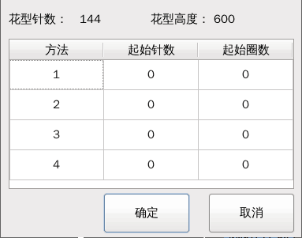
Description of main functions and parameters
The HC up function is auxiliary to the heel jacquard configuration function, and has the same role as the heel jacquard configuration function.

